# Tensorflow Object Detection API的使用

这个文档基于以下教程编写：

https://github.com/EdjeElectronics/TensorFlow-Object-Detection-API-Tutorial-Train-Multiple-Objects-Windows-10

## 环境准备

首先，安装好Tensowflow环境，我的环境是：

下载Tensorflow/models仓库，地址：<https://github.com/tensorflow/models.git>，在E:\tf_ws目录下：

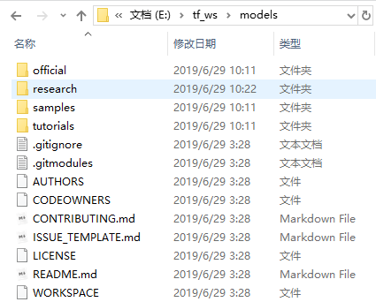

下载仓库：

https://github.com/EdjeElectronics/TensorFlow-Object-Detection-API-Tutorial-Train-Multiple-Objects-Windows-10，解压所有文件到models/research/object_detection目录下。

添加环境变量：PYTHONPATH

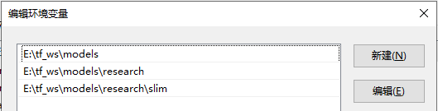

编译protobuf。在\models\research目录下执行：

|  |
| --- |
| protoc --python_out=. .\object_detection\protos\anchor_generator.proto .\object_detection\protos\argmax_matcher.proto .\object_detection\protos\bipartite_matcher.proto .\object_detection\protos\box_coder.proto .\object_detection\protos\box_predictor.proto .\object_detection\protos\eval.proto .\object_detection\protos\faster_rcnn.proto .\object_detection\protos\faster_rcnn_box_coder.proto .\object_detection\protos\grid_anchor_generator.proto .\object_detection\protos\hyperparams.proto .\object_detection\protos\image_resizer.proto .\object_detection\protos\input_reader.proto .\object_detection\protos\losses.proto .\object_detection\protos\matcher.proto .\object_detection\protos\mean_stddev_box_coder.proto .\object_detection\protos\model.proto .\object_detection\protos\optimizer.proto .\object_detection\protos\pipeline.proto .\object_detection\protos\post_processing.proto .\object_detection\protos\preprocessor.proto .\object_detection\protos\region_similarity_calculator.proto .\object_detection\protos\square_box_coder.proto .\object_detection\protos\ssd.proto .\object_detection\protos\ssd_anchor_generator.proto .\object_detection\protos\string_int_label_map.proto .\object_detection\protos\train.proto .\object_detection\protos\keypoint_box_coder.proto .\object_detection\protos\multiscale_anchor_generator.proto .\object_detection\protos\graph_rewriter.proto .\object_detection\protos\flexible_grid_anchor_generator.proto .\object_detection\protos\calibration.proto |

该命令会在models\object_detection\protos目录下生成pb2.py文件，如果后面执行训练命令时出现pb2找不到的情况，可能是生成的pb2.py文件不完全，查看object_detection\protos文件夹下还有什么文件没有加入到以上的命令上，加上云再生成一遍。

执行setup.py，在models\research目录下，执行：

|  |
| --- |
| python setup.py build  python setup.py install |

确认环境是否正常工作，在object_detection目录下，执行：

|  |
| --- |
| jupyter notebook object_detection_tutorial.ipynb |

执行各段代码：

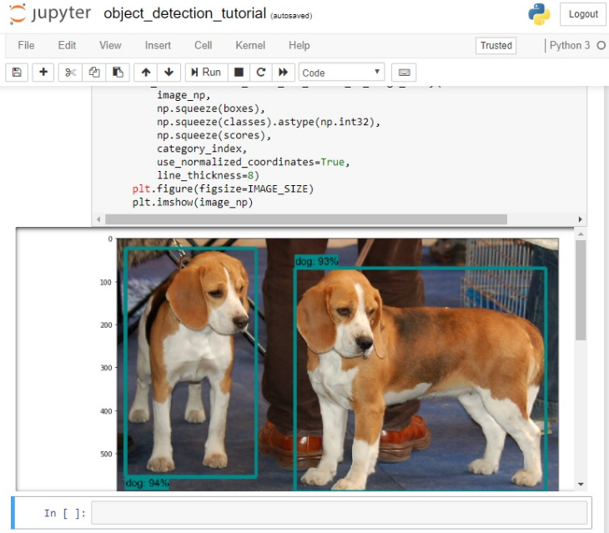

## 数据准备

使用标注精灵助手对图像进行标注，保存框为VOC格式，对标注好的数据，进行检查，如一些标注框超出图像范围，空标注文件等，进行检查修正，最后将数据按一定比例分成训练集和测试集，这里有参考的处理程序和代码：https://github.com/hy17003/voc_tools

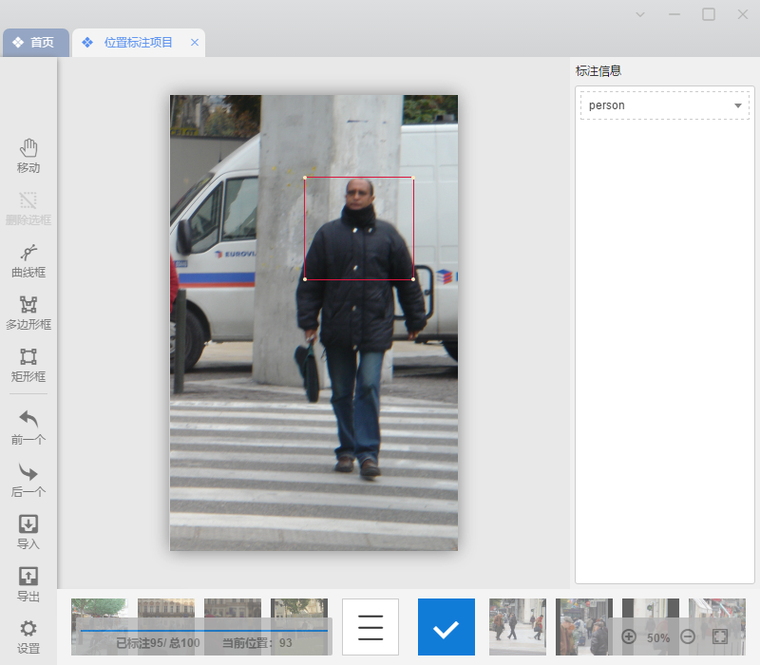

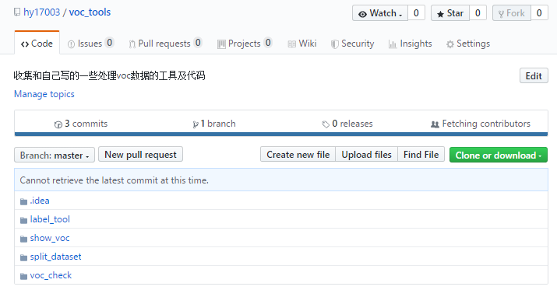

将训练数据包括图像和标注文件放到models\research\object_detection\images\train目录下：

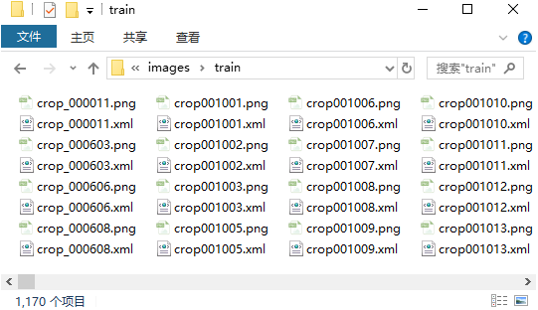

测试数据包括图像和文件放到models\research\object_detection\images\test目录下。

## 生成tfRecord文件

生成csv文件，在object_detection目录下执行：

|  |
| --- |
| python xml_to_csv.py |

在images目录下生成csv文件：

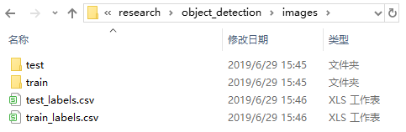

转成tfrecord文件，根据实际的目标类型，修改object_detection目录下的generate_tfrecord.py文件：

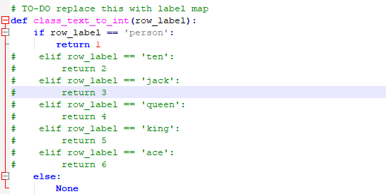

我这里只检测person这一类型。

执行：

|  |
| --- |
| python generate_tfrecord.py --csv_input=images\train_labels.csv --image_dir=images\train --output_path=train.record  python generate_tfrecord.py --csv_input=images\test_labels.csv --image_dir=images\test --output_path=test.record |

在\object_detection目录下生成**train.record**和**test.record**文件。

在object_detection/trainingh目录下创建**labelmap.pbtxt**文件，内容如下：

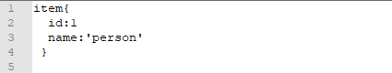

## 修改训练配置文件

这里使用ssd_mobilenet_v1模型进行微调，在object_detection/samples/configs中找到ssd_mobilenet_v1_coco.config文件，复制到object_detection\training文件夹中。

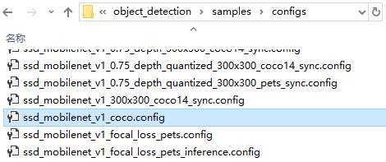

到以下地址下载相应的模型，解压到object_detecion/training文件夹中：

https://github.com/tensorflow/models/blob/master/research/object_detection/g3doc/detection_model_zoo.md

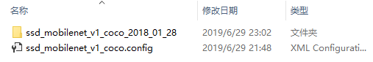

编辑ssd_mobilenet_v1_coco.config文件，主要修改类型的数量，这里只有一类，修改为1，相关数据的地址PATH_TO_BE_CONFIGURED，批大小batch_size，这埯改成16

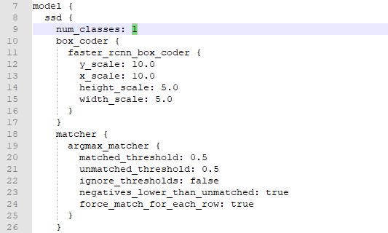

## 训练

将object_detection\legacy目录下的train.py文件拷贝到object_detection目录下。

在E:\tf_ws\models\research\object_detection目录下执行：

|  |
| --- |
| python train.py --logtostderr --train_dir=training/ --pipeline_config_path=training/ssd_mobilenet_v1_coco.config |

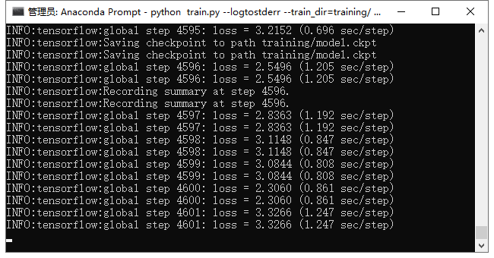

训练过程中，在object_detection目录下执行：

|  |
| --- |
| tensorboard --logdir=training |

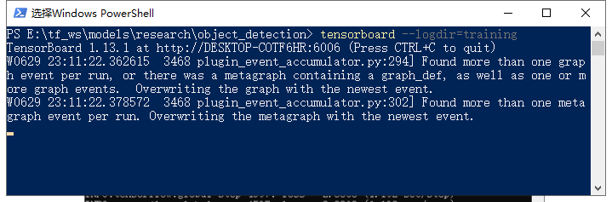

使用浏览器，打开http://desktop-cotf6hr:6006，我这里使用的是Micosoft Edge浏览器：

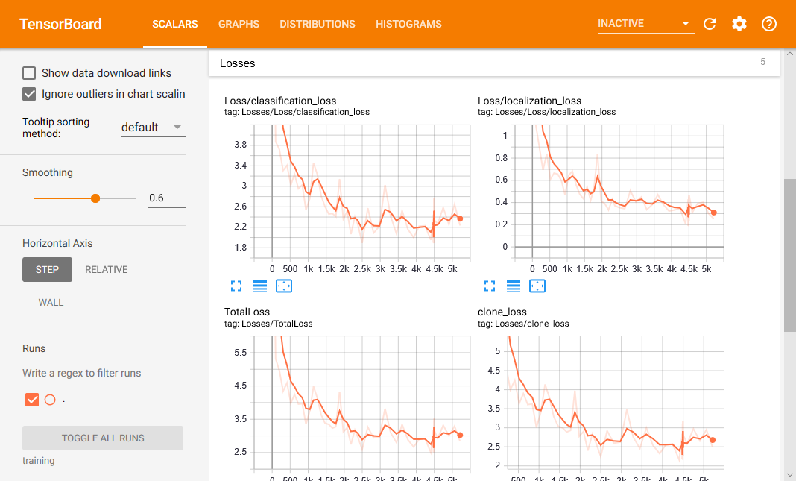

## 生成ffrozen_inference_graph.pb文件

在object_detection目录下，执行：

|  |
| --- |
| python export_inference_graph.py --input_type image_tensor --pipeline_config_path training/ssd_mobilenet_v1_coco.config --trained_checkpoint_prefix training/model.ckpt-71395 --output_directory inference_graph |

其中71395根据自己情况做修改。

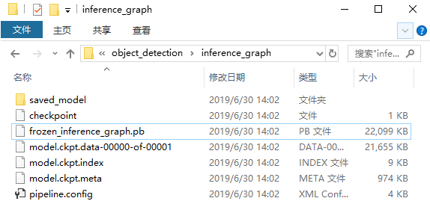

## 测试

|  |
| --- |
| # Import packages  **import** os  **import** cv2  **import** numpy **as** np  **import** tensorflow **as** tf  **import** sys  # This is needed since the notebook is stored in the object_detection folder.  sys**.**path**.**append**(**".."**)**  # Import utilites  **from** utils **import** label_map_util  **from** utils **import** visualization_utils **as** vis_util  # Name of the directory containing the object detection module we're using  MODEL_NAME **=** 'inference_graph'  # Grab path to current working directory  CWD_PATH **=** os**.**getcwd**()**  # Path to frozen detection graph .pb file, which contains the model that is used  # for object detection.  PATH_TO_CKPT **=** os**.**path**.**join**(**CWD_PATH**,**MODEL_NAME**,**'frozen_inference_graph.pb'**)**  NUM_CLASSES **=** 1  # Path to label map file  PATH_TO_LABELS **=** os**.**path**.**join**(**CWD_PATH**,**'training'**,**'labelmap.pbtxt'**)**  label_map **=** label_map_util**.**load_labelmap**(**PATH_TO_LABELS**)**  categories **=** label_map_util**.**convert_label_map_to_categories**(**label_map**,** max_num_classes**=**NUM_CLASSES**,** use_display_name**=True)**  category_index **=** label_map_util**.**create_category_index**(**categories**)**  # Load the Tensorflow model into memory.  detection_graph = tf.Graph()  with detection_graph.as_default():  od_graph_def = tf.GraphDef()  with tf.gfile.GFile(PATH_TO_CKPT, 'rb') as fid:  serialized_graph = fid.read()  od_graph_def.ParseFromString(serialized_graph)  tf.import_graph_def(od_graph_def, name='')  sess = tf.Session(graph=detection_graph)  # Define input and output tensors (i.e. data) for the object detection classifier  # Input tensor is the image  image_tensor = detection_graph.get_tensor_by_name('image_tensor:0')  # Output tensors are the detection boxes, scores, and classes  # Each box represents a part of the image where a particular object was detected  detection_boxes = detection_graph.get_tensor_by_name('detection_boxes:0')  # Each score represents level of confidence for each of the objects.  # The score is shown on the result image, together with the class label.  detection_scores = detection_graph.get_tensor_by_name('detection_scores:0')  detection_classes = detection_graph.get_tensor_by_name('detection_classes:0')  # Number of objects detected  num_detections = detection_graph.get_tensor_by_name('num_detections:0')  IMAGE_LIST = os.listdir('test_images')  for IMAGE_NAME in IMAGE_LIST:  # Path to image  PATH_TO_IMAGE = os.path.join(CWD_PATH, 'test_images', IMAGE_NAME)  # Load image using OpenCV and  # expand image dimensions to have shape: [1, None, None, 3]  # i.e. a single-column array, where each item in the column has the pixel RGB value  image = cv2.imread(PATH_TO_IMAGE)  image_expanded = np.expand_dims(image, axis=0)  # Perform the actual detection by running the model with the image as input  (boxes, scores, classes, num) = sess.run(  [detection_boxes, detection_scores, detection_classes, num_detections],  feed_dict={image_tensor: image_expanded})  # Draw the results of the detection (aka 'visulaize the results')  vis_util.visualize_boxes_and_labels_on_image_array(  image,  np.squeeze(boxes),  np.squeeze(classes).astype(np.int32),  np.squeeze(scores),  category_index,  use_normalized_coordinates=True,  line_thickness=8,  min_score_thresh=0.8)  # All the results have been drawn on image. Now display the image.  cv2.imshow('Object detector', image)  # Press any key to close the image  cv2.waitKey(0)  # Clean up  cv2.destroyAllWindows() |

